

Department of Statistics

STAT 311
Modern Database Systems

Term Project
“CineLOG
Movie & Series Tracking Database System”

By

İsmet Selman LOĞOĞLU, 2507515
Betül ÖĞRETEN, 2502276
Dilara ARSLANTAŞ, 2498335
Melike CANTÜRK, 2523330

METU
Fall, 2025
Table of Contents

ER Diagram……................................................................................................................... 1
Introduction .......................................................................................................................... 2
Schema Designs and Table.................................................................................................... 3

Query Executing…………………………………………………………………………….4

UI Showcase………………………………………………………………………...………5

References…………………………………………………………………………………..6

Database Entity Relations Diagram

Figure 1

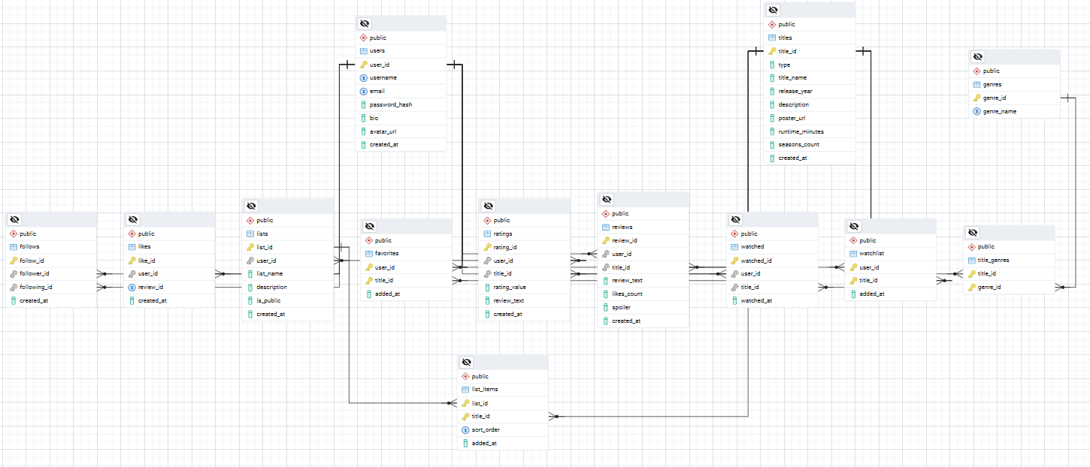

Entity–Relationship (ER) Diagram of the Cielog Database Schema from PostgreSQL

Figure 2
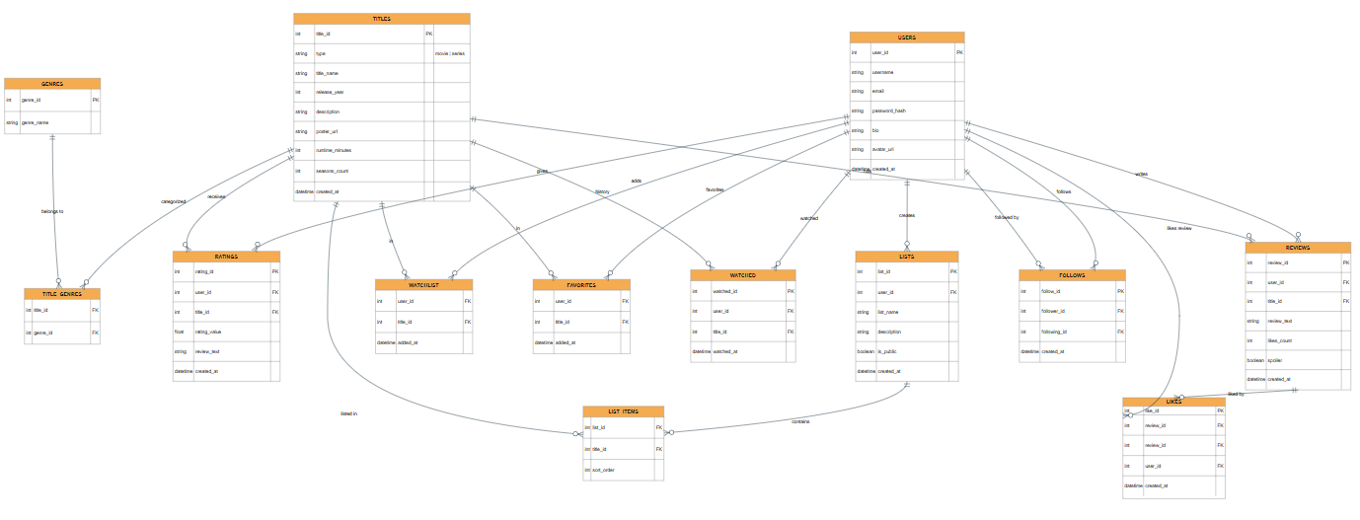

Database Schema and Relationship Diagram of the Cielog System

Introduction

Accessing movies and TV shows is now easier than ever, yet tracking what users watch in an organized way, such as what they watched, when they watched it, and how they evaluated it, often becomes fragmented in practice. CineLog was designed and implemented as a relational database–driven tracking system that addresses this need by systematically storing viewing activity and managing essential information about films in a consistent manner.
Within the scope of the project, the core entities and relationships required to support viewing tracking were modeled, and data integrity and consistency were ensured through appropriate keys and constraints. As a result, users’ watch history and evaluation records can be stored in a structured and extensible form.
In addition to the database, the project includes a user interface (UI) that supports the main workflows of the system. Users can browse and filter titles, view relevant details, and create/manage their personal records (such as watch entries and ratings) through a straightforward interaction flow.
- User: Stores personal and contact information of users.
- Title: Represents each movie or series, including attributes like release year, duration, and type.
- Season and Episode: Used to represent series and their episodes in hierarchical form (1-N).
- Genre: Linked to titles through TitleGenre (N–M) to allow multiple genres per title.
- Person: Includes directors, actors, and writers; connected to titles via TitlePerson (N–M).
- Platform: Represents streaming services (e.g., Netflix, Disney+, Prime Video); connected through Availability (N–M) to indicate which platform offers which title.
- WatchHistory: Records when and how long a user watched a title.
- Rating: Contains users’ ratings (1–10) and optional written reviews for each title.
- List and ListItem: Allow users to create custom watchlists by linking users and titles (N–M).
Each foreign key is defined with ON DELETE CASCADE to maintain referential integrity.
Additional constraints include CHECK rules (e.g., rating range, year validity, type domain) and UNIQUE keys for critical attributes like email and genre name.
Main Functionalities / Research Questions:
- A user’s complete watch history: “What have I watched and when?”
- List top-rated titles by genre, platform, or time period.
- Find titles similar to those a user liked (based on genre/cast/director).
- See which titles are commonly liked by users with similar rating patterns.
- Which genres or directors are most frequently watched?
- What is the average rating per genre or platform?
- How many titles has each user watched and rated?
- What are the most common release years among watched titles?
- How much total watch time has a user accumulated over a given period?
- Which platforms host the largest number of titles in specific regions?
- How do user ratings vary across different genres and production years.
Schema Designs and Tables

USERS Schema

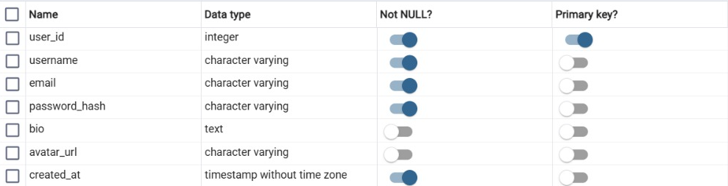

USERS schema defines the structure of the USERS table, stores information about the users of the system. The USERS table is a core of the system and all other tables in the database are linked to this table via foreign keys.
- user_id is a primary key of the table. It uniquely identifies each user in the system.
- username, stores the unique usernames of the users, and it cannot be null, means that every user must have a username.
- email is a character varying that stores user’s email address and cannot be null.
- Password_hash, stores the user’s hashed password for security purposes and cannot be null.
- bio is a text attribute and stores information about the users, this field can be null.
- avatar_url , stores the URL of the user’s profile image, it is optional.
- created_at is a timestamp attribute and it is not null with default value NOW( ), stores creation time.

USERS Table

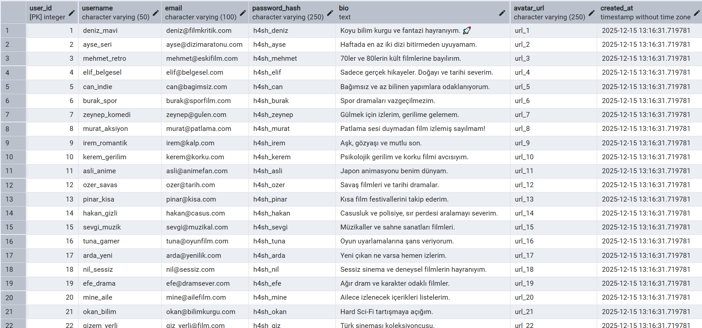
avatar_url and user_id starts with 1 and automatically increase when a user enters the system. Since all users added to the system with INSERT and NOW( ), created_at attribute is same for all users.

LISTS Schema

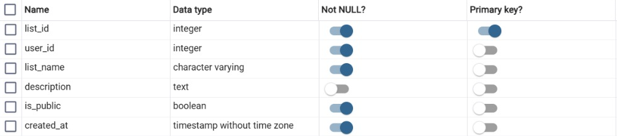

Lists table stores user’s lists, users can create multiple lists, but a list must belong to only one user. (1:N)
- list_id is a primary key with serial attribute, it is unique and naturally cannot be null.
- user_id is a foreign key, and it is reference to the users table.
- list_name stores the names of the lists and cannot be null.
- description is a text attribute, and it is optional for users.
- Is_public is a boolean attribute and it cannot be null, if it is null system automatically assign TRUE as a default.
- created_at is timestamp attribute and with default value NOW( ) it cannot be null.

LISTS Table

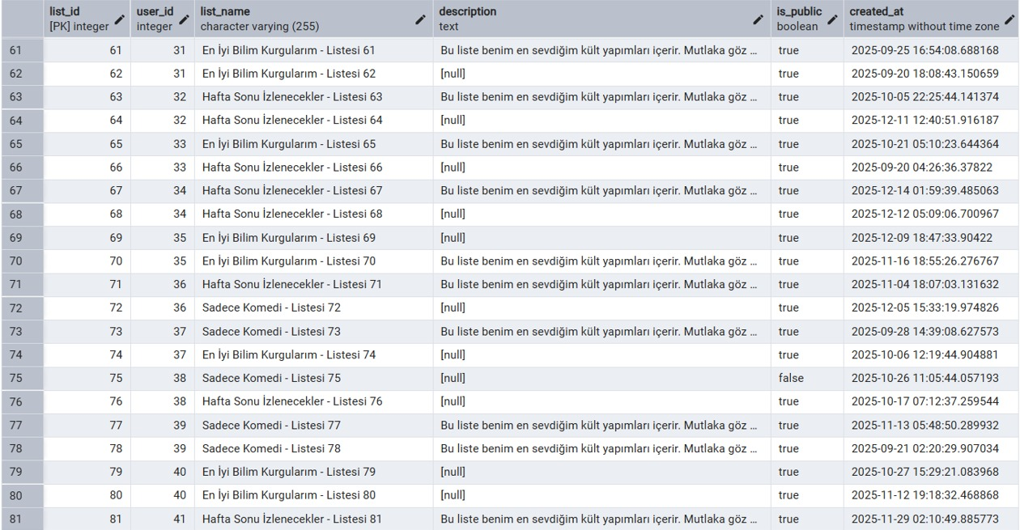

FOLLOWS Schema

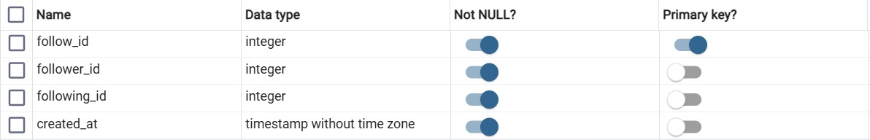

Follows table shows recursive relationships with users. Users can follow multiple users also followed by multiple users that shows many to many relationships. (M: N). For follower_id and following_id UNIQUE constraint added to avoid duplicating. Also, with CHECK constraint between follower_id and following_id users cannot follow themselves. ON DELETE CASCADE is used to preserve referential integrity. If a user which is parent record automatically removed and the entire follow record is deleted.

- follow_id is a primary key and cannot be null.
- follower_id is a foreign key referencing to the users table, and it is unique.
- following_id is also foreign key referencing to the users table.
- created_at is a timestamp attribute and with default NOW ( ), it cannot be null.

FOLLOWS Table

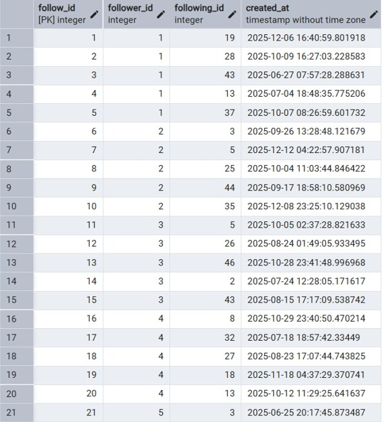

WATCHED Schema

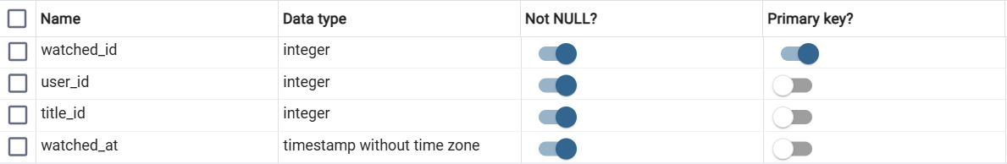

Watched table is linked both users and titles table. It is shows which titles has been watched by which user and when. Each record belongs to only one user and one title. Users may not have any watched history or have multiple records. ON DELETE CASCADE preserve referential integrity if a user or title deletes automatically record is deleting.

- watched_id is a primary key with serial, shows watch record, cannot be null and unique.
- user_id is a foreign key referencing to users table.
- title_id is a foreign key referencing to title table.
- watched_at is a timestamp attribute it records watched time and cannot be null.

WATCHED Table

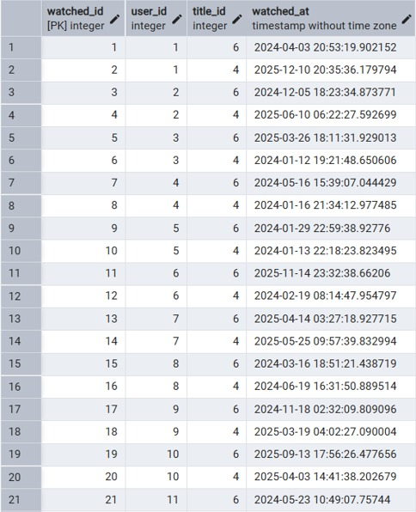

WATCHLIST Schema

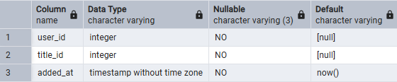
WATCHLIST schema defines the structure of the WATCHLIST table and stores information about titles that users plan to watch. Each record belongs to exactly one user and one title. Users may have zero or many WATCHLIST records, and each title can appear in the watchlist of many users, which creates an N:M relationship between USERS and TITLES through this table.
- user_id is a foreign key referencing the USERS table. It identifies which user the watchlist record belongs to and it cannot be null.
- title_id is a foreign key referencing the TITLES table. It shows which title is added to the watchlist and it cannot be null.
- added_at is a timestamp attribute that stores when the title was added to the watchlist. It is not null and has the default value NOW().
- The composite primary key (user_id, title_id) ensures that the same title cannot be added more than once to the watchlist of the same user.
WATCHLIST Table
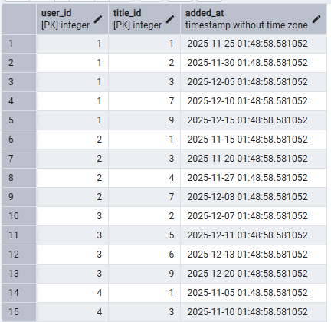
The sample data for the WATCHLIST table shows how user–title pairs are stored together with their added_at timestamps. Each row represents one title that a specific user plans to watch, and each user–title combination appears at most once, which enforces that a user cannot add the same title to their watchlist more than once and illustrates 1:N relationships from USERS to WATCHLIST and from TITLES to WATCHLIST.

FAVORITES Schema

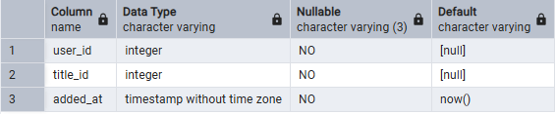
FAVORITES schema defines the structure of the FAVORITES table and stores titles that users mark as their favorites. Each record connects one user and one title and represents that the user especially likes this title. Similar to WATCHLIST, this table also creates an N:M relationship between USERS and TITLES.
- user_id is a foreign key referencing the USERS table and it cannot be null. It indicates which user marked the title as favorite.
- title_id is a foreign key referencing the TITLES table and it cannot be null. It indicates which title is marked as favorite.
- added_at is a timestamp attribute that stores when the title was added to the favorites list. It is not null and uses NOW() as the default value.
- The primary key (user_id, title_id) prevents duplicate favorite records for the same user and the same title.
FAVORITES Table
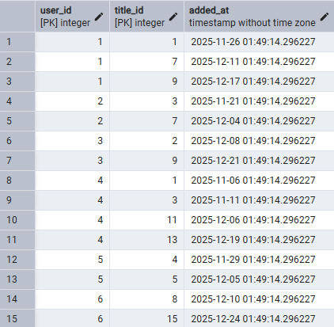
The sample data for the FAVORITES table shows user–title pairs together with their added_at timestamps. Each row represents one title that a specific user has marked as favorite, and each user–title combination appears at most once, reflecting the 1:N relationships from USERS to FAVORITES and from TITLES to FAVORITES.

LIST_ITEMS Schema
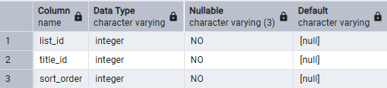
LIST_ITEMS schema defines the structure of the LIST_ITEMS table and stores which titles belong to each user-created list. Each record belongs to exactly one list and one title, and also stores the position of the title inside that list. Lists can have many items, but each item belongs to only one list (1:N between LISTS and LIST_ITEMS). There are N:M relationship between LISTS and TITLES, with sort_order preserving the order of items inside each list.
- list_id is a foreign key referencing the LISTS table and it cannot be null. It shows which list the item belongs to.
- title_id is a foreign key referencing the TITLES table and it cannot be null. It indicates which title is included in the list.
- sort_order is an integer attribute that stores the position of the title in the list. It cannot be null and is constrained to be greater than or equal to 1.
- The composite primary key (list_id, title_id) ensures that the same title cannot appear more than once in the same list.
- The unique constraint on (list_id, sort_order) ensures that each position in a list is used only once, so there cannot be two items with the same order in the same list.
LIST_ITEMS Table
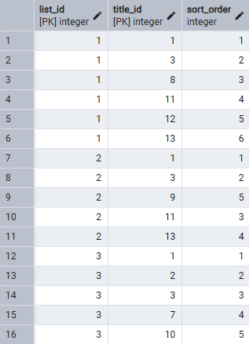
The sample data for LIST_ITEMS shows which titles belong to each list together with their sort_order values. Each row represents one title in a specific list, and the composite primary key (list_id, title_id) ensures that the same title cannot appear more than once in the same list while supporting 1:N relationships from LISTS and TITLES to LIST_ITEMS.

GENRES Schema
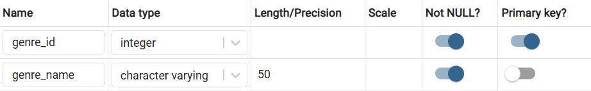

GENRES Table
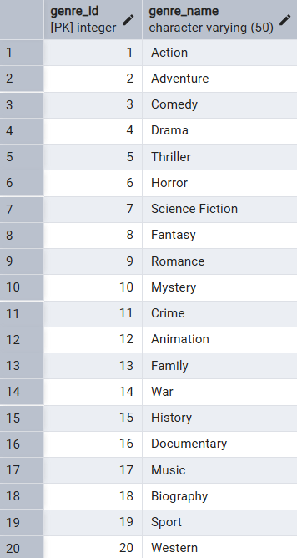
The GENRES schema defines the structure of the GENRES table, which stores genre information for movies and TV series in the system. The genre_id field is defined as the primary key of the table and uniquely identifies each genre. The genre_name field stores the name of the genre and is defined as NOT NULL to ensure that every genre has a valid name. In addition, the genre_name field is defined as UNIQUE to prevent duplicate genre entries in the table. The GENRES table is linked to the TITLES table through the TITLE_GENRES table, which enables a many-to-many relationship between titles and genres.

TITLES Schema

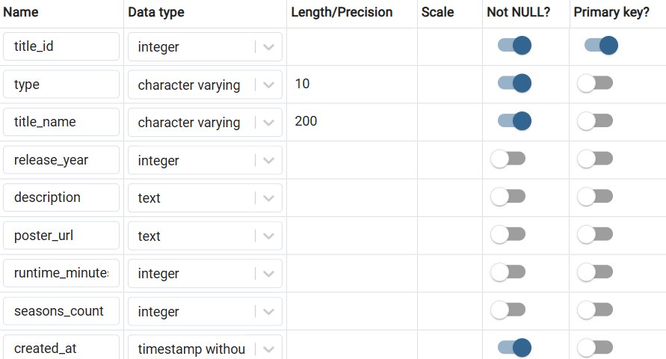

The TITLES schema defines the structure of the TITLES table, which stores the main information about movies and TV series in the system. The title_id field is defined as the primary key of the table and uniquely identifies each title. The type field is used to distinguish between movies and TV series. Additional attributes such as release year, description, runtime, and season count are stored in this table to provide detailed information about each title. The TITLES table is referenced by several other tables, including RATINGS and TITLE_GENRES, to associate user interactions and genre information with each title.

TITLES Table
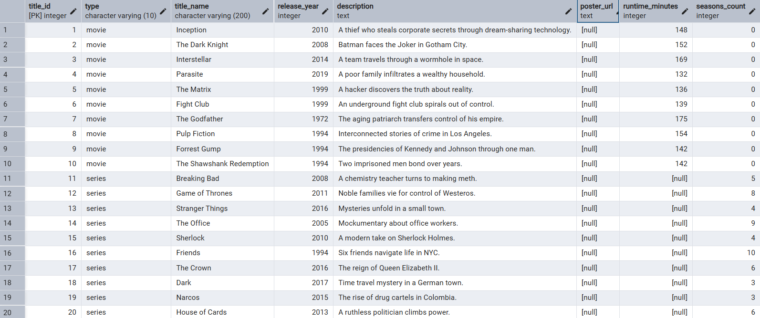

TITLES_GENRES Schema
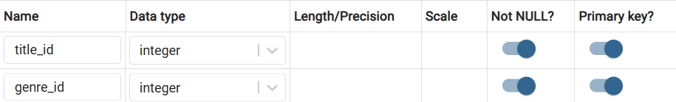

TITLE_GENRES Table

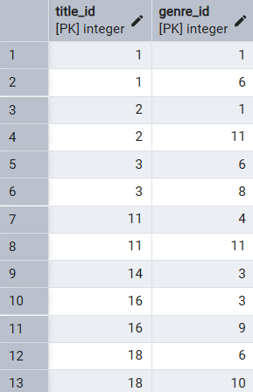
The TITLE_GENRES schema defines the structure of the TITLE_GENRES table, which represents the many-to-many relationship between titles and genres in the system. Each record in this table links one title to one genre. The title_id and genre_id fields are defined as foreign keys that reference the TITLES and GENRES tables, respectively. This structure allows a single title to be associated with multiple genres, while the same genre can also be linked to multiple titles.

RATING Schema

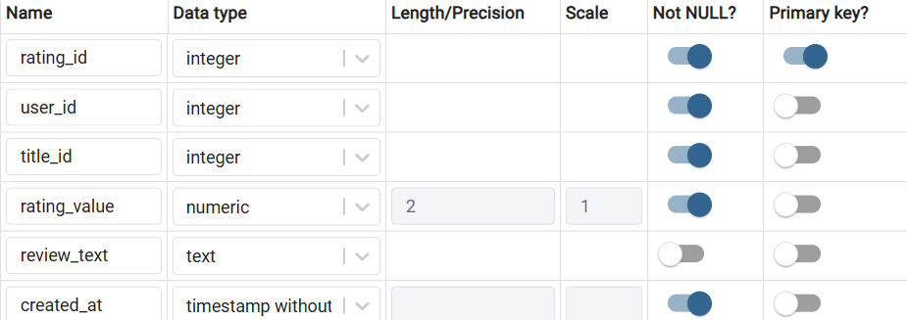

The RATINGS schema defines the structure of the RATINGS table, which stores user ratings and optional reviews for movies and TV series in the system. Each rating record is associated with one user and one title. The user_id and title_id fields are defined as foreign keys that reference the USERS and TITLES tables, ensuring that ratings are only created for existing users and titles. The rating_value field stores the numerical score given by the user, while the review_text field allows users to provide an optional written comment. The created_at field records the date and time when the rating was created.

RATING Table

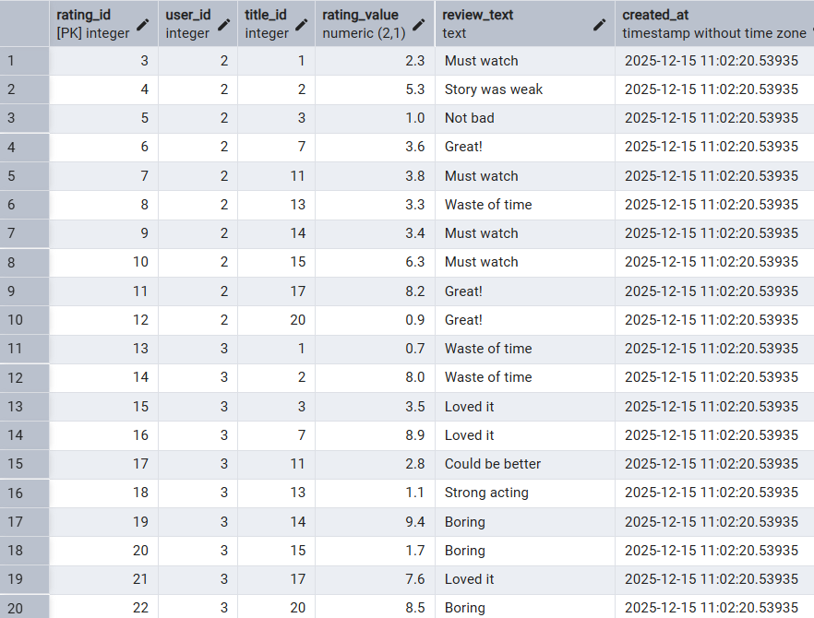

LIKES Schema

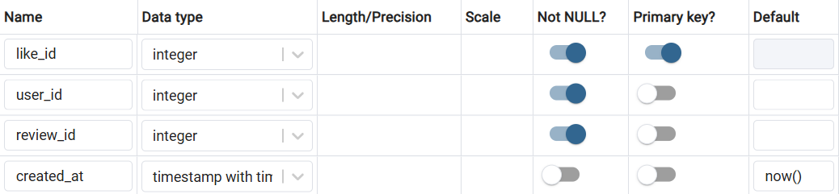

The LIKES schema defines the structure of the LIKES table, which stores information about likes given by users to reviews in the system. Each like record is associated with one user and one review. The user_id and review_id fields are defined as foreign keys that reference the USERS and REVIEWS tables, ensuring that likes are only created by existing users and for existing reviews. The like_id field is defined as the primary key and uniquely identifies each like record. The created_at field records the date and time when the like was created, allowing the system to track user interaction and engagement over time.

LIKES Table

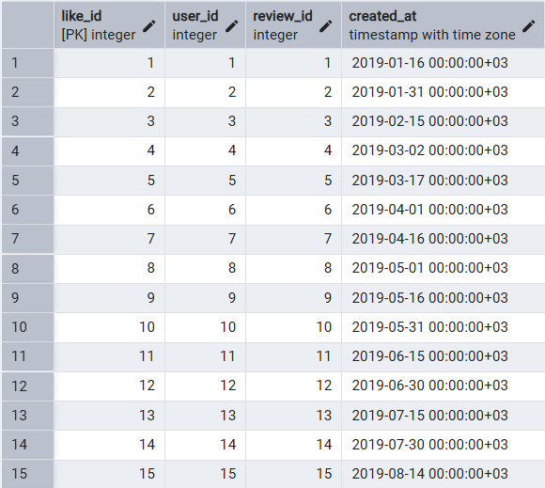

Reviews Schema

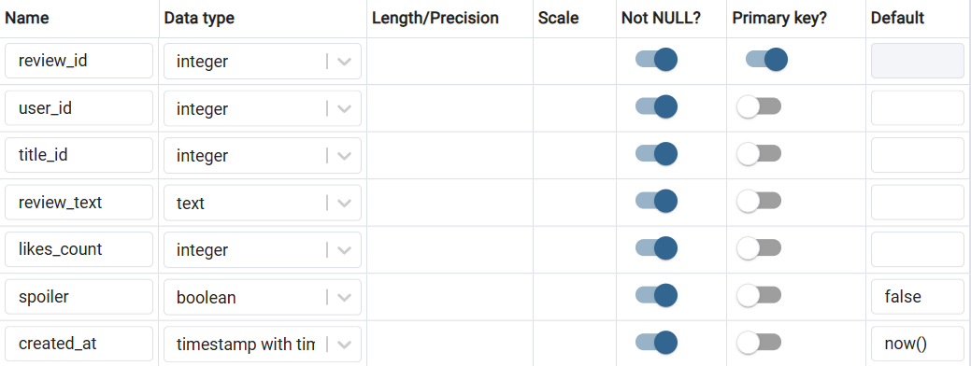

The REVIEWS schema defines the structure of the REVIEWS table, which stores written reviews created by users for movies and TV series in the system. Each review record is associated with one user and one title. The user_id and title_id fields are defined as foreign keys that reference the USERS and TITLES tables, ensuring that reviews are only created by existing users and for existing titles. The review_id field is defined as the primary key and uniquely identifies each review record. The review_text field stores the written content of the review, while the likes_count field stores the total number of likes received by the review. The spoiler field is a boolean value that indicates whether the review contains spoiler information, helping users avoid unwanted content. The created_at field records the date and time when the review was created.

Reviews Table

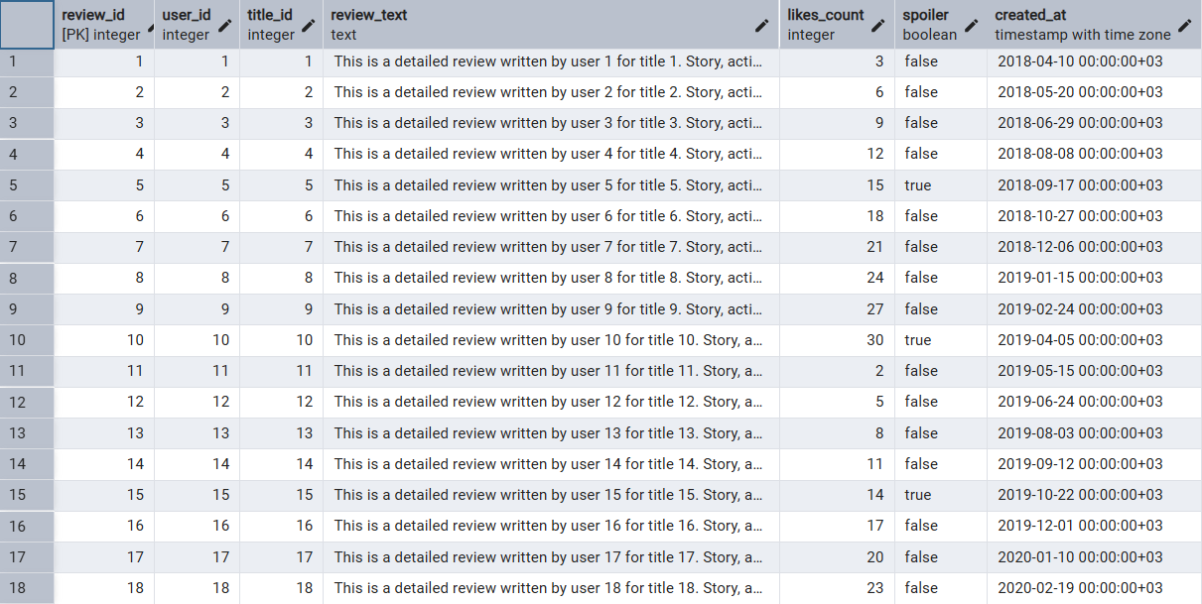

Executing Some Queries

Top 10 Most Watched Titles

$$SELECT$$
$$t.title_name,$$
$$COUNT(w.user_id) AS watch_count$$
$$FROM watched w$$
$$JOIN titles t ON t.title_id = w.title_id$$
$$GROUP BY t.title_name$$
$$ORDER BY watch_count DESC$$
$$LIMIT 10;$$

Table 1.
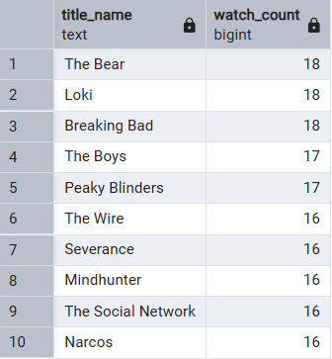
Top 10 Most Watched Titles Based on User Watch Counts

Top 10 Titles with the Highest Favorite

$$SELECT$$
$$t.title_name,$$
$$COUNT(f.user_id) AS favorite_count$$
$$FROM favorites f$$
$$JOIN titles t ON t.title_id = f.title_id$$
$$GROUP BY t.title_name$$
$$ORDER BY favorite_count DESC$$
$$LIMIT 10;$$

Table 2.
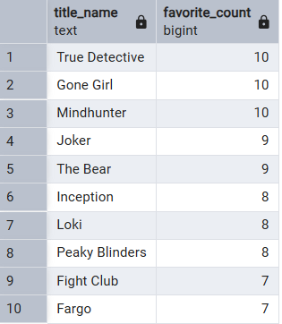
Top 10 Titles with the Highest Favorite Count
User-Based Watch Counts by Title Type

$$SELECT$$
$$u.username,$$
$$t.type,$$
$$COUNT(*) AS watched_count$$
$$FROM watched w$$
$$JOIN users u ON u.user_id = w.user_id$$
$$JOIN titles t ON t.title_id = w.title_id$$
$$WHERE u.username IN ($$
$$'melike.canturk',$$
$$'dilara.arslantas',$$
$$'betul.ogreten',$$
$$'ismetloglu'$$
$$)$$
$$GROUP BY u.username, t.type$$
$$ORDER BY u.username, watched_count DESC;$$

Table 3.
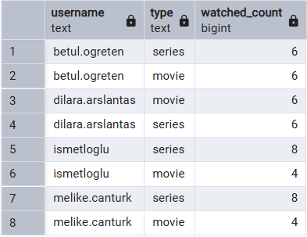
User-Based Watch Counts by Title Type

Cinelog UI Showcase

Secure Access

Admin & User Login
The entry point to the application features a clean, centered login form. It provides secure access validation and includes helpful hints for demo purposes. The design focuses on minimizing distractions to ensure a smooth entry into the dashboard.
- Clean, centered card design
- Input validation
- Error feedback handling
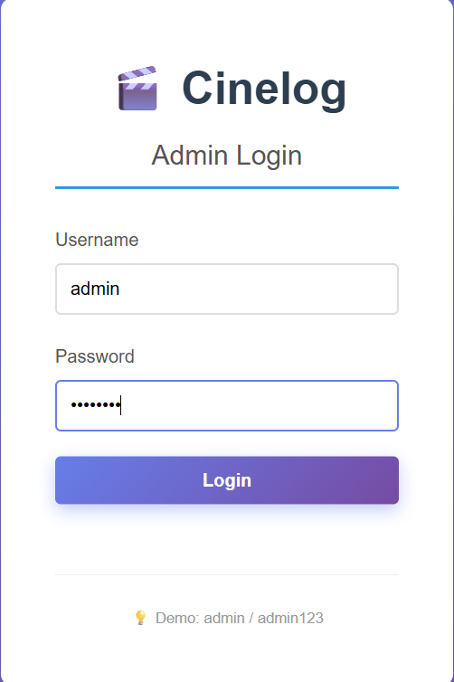
Content Discovery

Movies & Series Catalog
The core of the application is the catalog view. Users can browse through an extensive collection of titles. The interface includes powerful tools to find exactly what you're looking for.
- Search: Instant title search
- Filtering: Filter by Type (Movie/Series) and Genre
- Sorting: Sort by Rating or Popularity (Likes)
- Grid Layout: Responsive grid displaying posters and key info

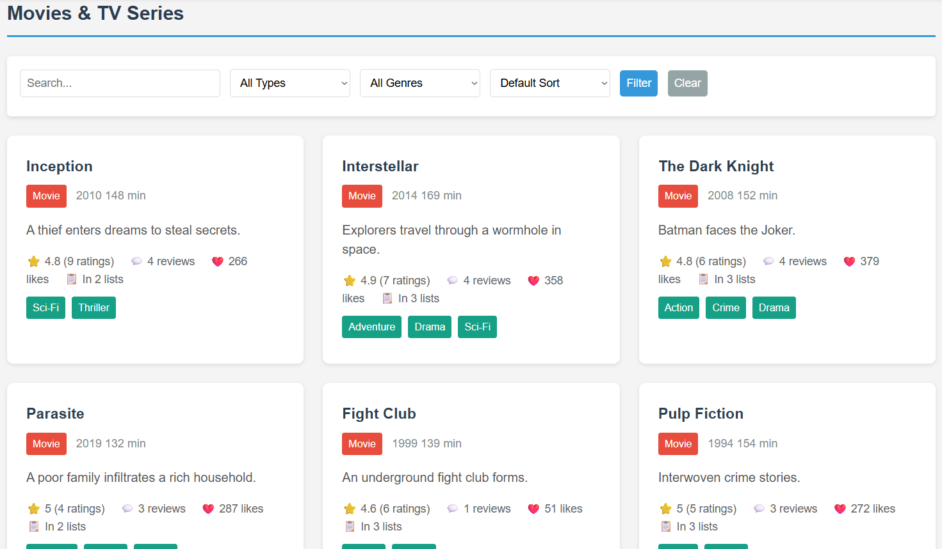
Community Management

User Directory
Administrators can manage the user base through a dedicated interface. This section allows for searching and viewing user profiles, ensuring the community remains active and moderated.

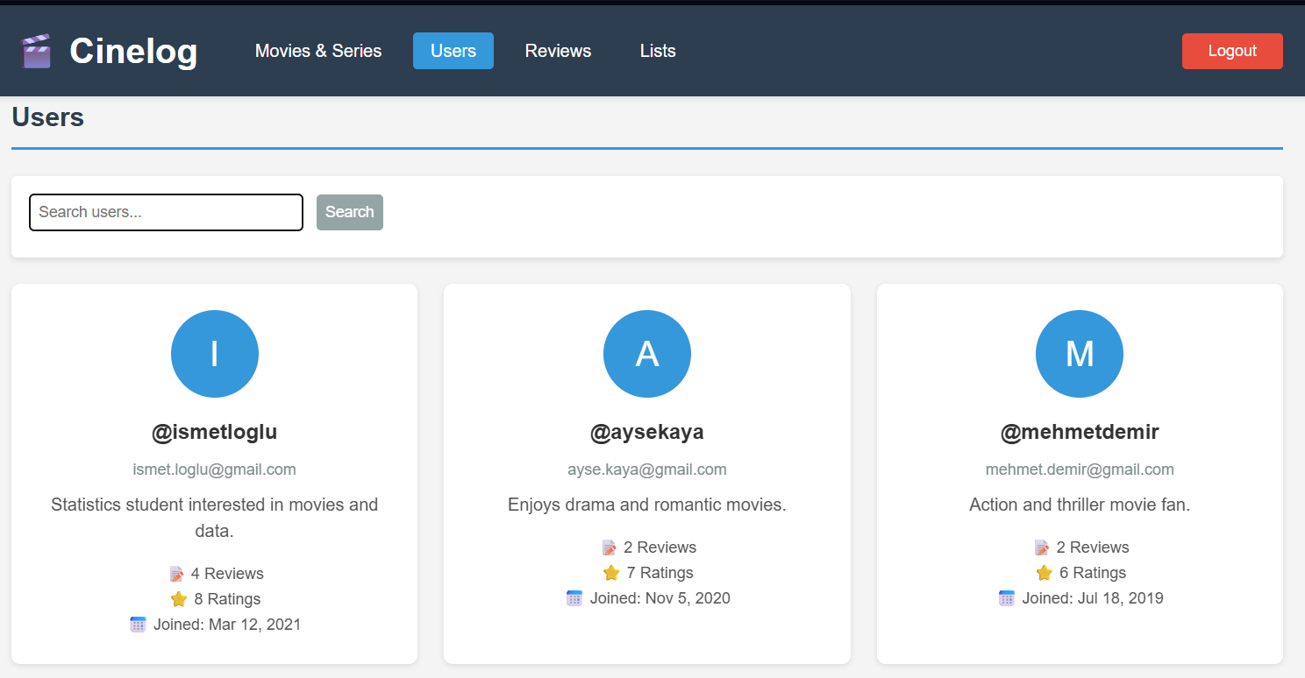

Reviews Submitted

Reviews Section
The Reviews section allows users to view and explore reviews written by other users for movies and TV series. Each review card displays the username, title name, rating score, review text, number of likes, and creation date. Users can filter reviews by movie or series to easily find relevant content. This section supports community interaction by highlighting user opinions and feedback.

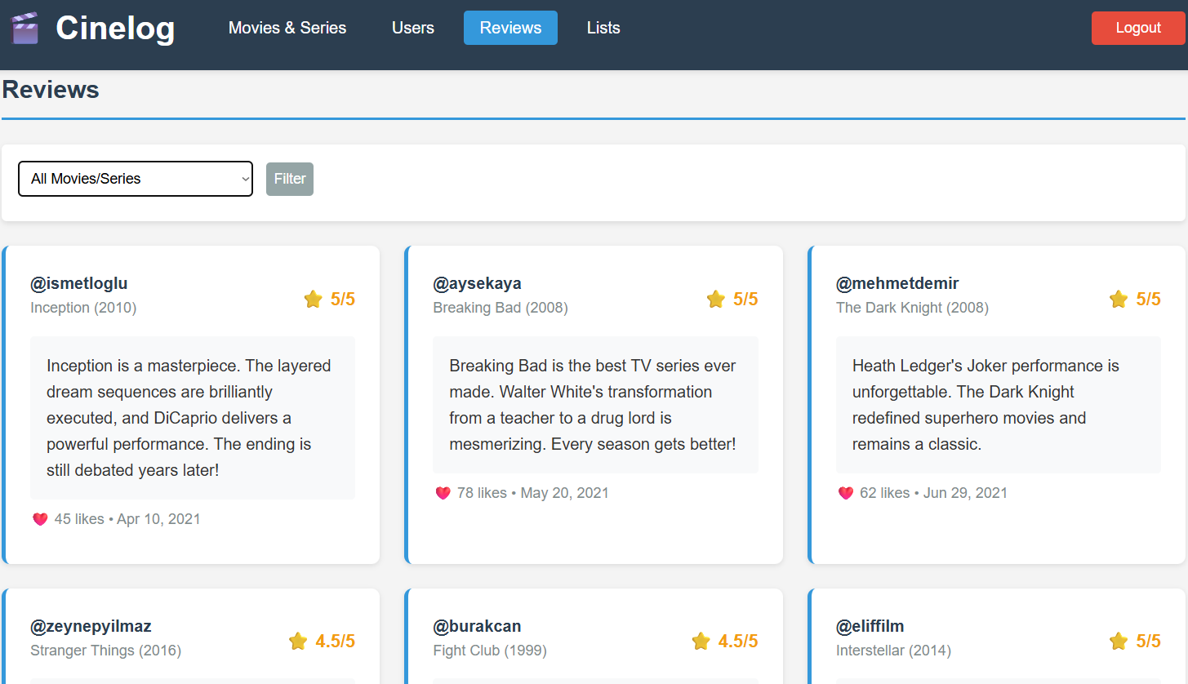

Lists Created

User Lists
The Lists section allows users to create and share personalized lists of movies and TV series. Each list includes a title, description, creator information, number of items, visibility status, and creation date. Public lists can be viewed by all users, making it easier to discover curated recommendations. This feature encourages content organization and user engagement within the platform.

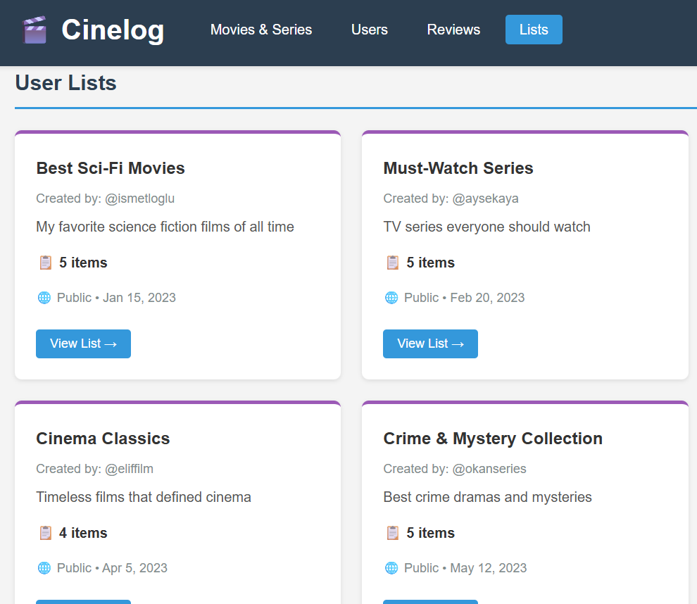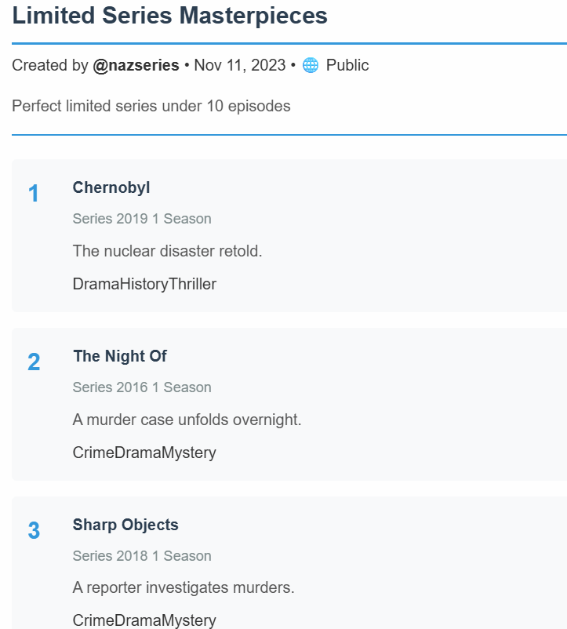

Author Contributions

This project was carried out based on a project roadmap agreed upon collectively by all team members. During the planning phase, the overall scope and structure of the system were discussed collaboratively, and a brainstorming process was conducted to identify the required entities in the database. Following this process, tasks were distributed evenly among the team members. Throughout the project, the team worked synchronously on a shared database environment, and the development process was conducted as a collaborative team effort.

Betül was responsible for the design and implementation of the USERS, LISTS, FOLLOWS, and WATCHED tables. Her work focused on modeling user accounts, social relationships, and viewing history, as well as defining the necessary constraints and relationships for these tables.

Dilara designed and implemented the WATCHLIST, FAVORITES, and LIST_ITEMS tables. She focused on representing user-specific collections and lists and on establishing the relationships between users, lists, and titles within the database.

Melike was responsible for the GENRES, TITLES, TITLE_GENRES, and RATINGS tables, which form the core content and evaluation structure of the system. This included defining genre–title relationships, managing rating and review data, and ensuring the correct application of primary and foreign key constraints.

İsmet designed the Entity–Relationship (ER) diagram and developed the user interface (UI) of the system. He was also responsible for implementing the LIKES and REVIEWS tables, which support user interactions and feedback mechanisms within the platform.

At the final stage, the presentation and the written report were prepared collaboratively by all team members.

References

Prisma. (n.d.). Prisma documentation. https://www.prisma.io/docs

PostgreSQL Global Development Group. (n.d.). PostgreSQL documentation. https://www.postgresql.org/docs/

Mozilla Developer Network. (n.d.). HTML: HyperText Markup Language. https://developer.mozilla.org/en-US/docs/Web/HTML

Mozilla Developer Network. (n.d.). CSS: Cascading Style Sheets. https://developer.mozilla.org/en-US/docs/Web/CSS

Draw.io. (n.d.). Draw.io diagramming tool. https://www.drawio.com/

